**Self-Registration for Online Password Reset Tool**

**STEP 1**

# Go to this link: [http://passwordregister.dpcdsb.org](http://passwordregister.dpcdsb.org/)

**STEP 2**

Enter ***school email*** (student#@educ.dpcdsb.org) & DPCDSB password to sign in.

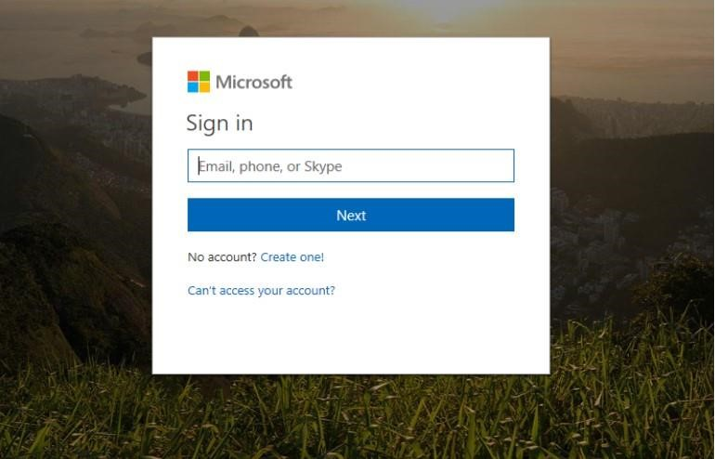

You will be asked if you want to **“Stay signed in?”** Click **Yes** or **No**.

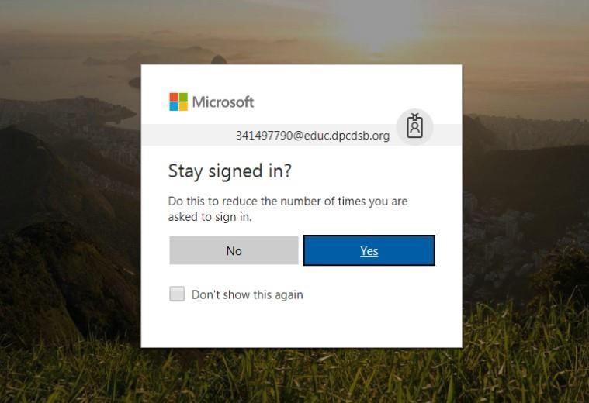

Click on “**Set it up now**” on at least one of the options:

**Cell phone number** OR **Personal email**

**Choose an option which is easier for you to access, you will need that to retrieve a Verification Code. You will also need that later when you want to reset password online.

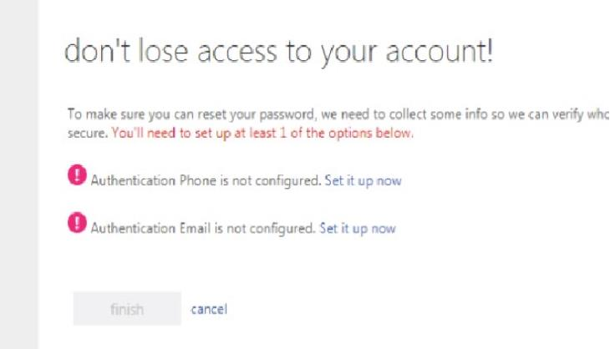

Set up with **cell phone number**

* Select Country
* Enter Cell number

-

Click on

**text me**

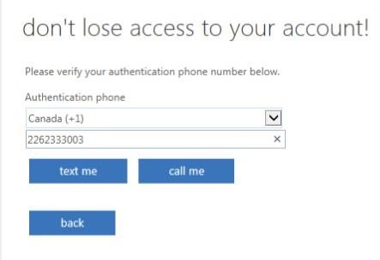

# OR

Set up with **personal email**

- Enter personal email address

-

Click on

**email me**

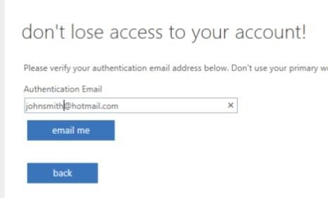

**STEP 6**

Retrieve **Verification Code** from cellphone or from inbox of personal email account Enter Verification Code – Click on ***verify***

Wait for verification to finish.

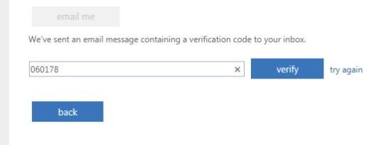

Successful

set up

is

indicated by

***g***

***reen***

***checks***

beside cell n

umber

and/or email address used

.

Click on

***finish***

to complete registration.

Congratu

lations, you are now registered!

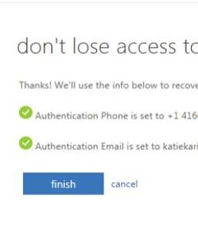

Students who registered successfully may use the following link to reset password online.

## [http://passwordreset.dpcdsb.org](http://passwordreset.dpcdsb.org/)

* Anytime - when password expires, when account is locked, or when password is forgotten
* Anywhere - at school, at home or anywhere with internet connection
* On any device - school computers/chrome books or own devices